Newby Hall Information
Northern National Dahlia Show 2020
Site map
How to find Newby Hall
Local Accommodation

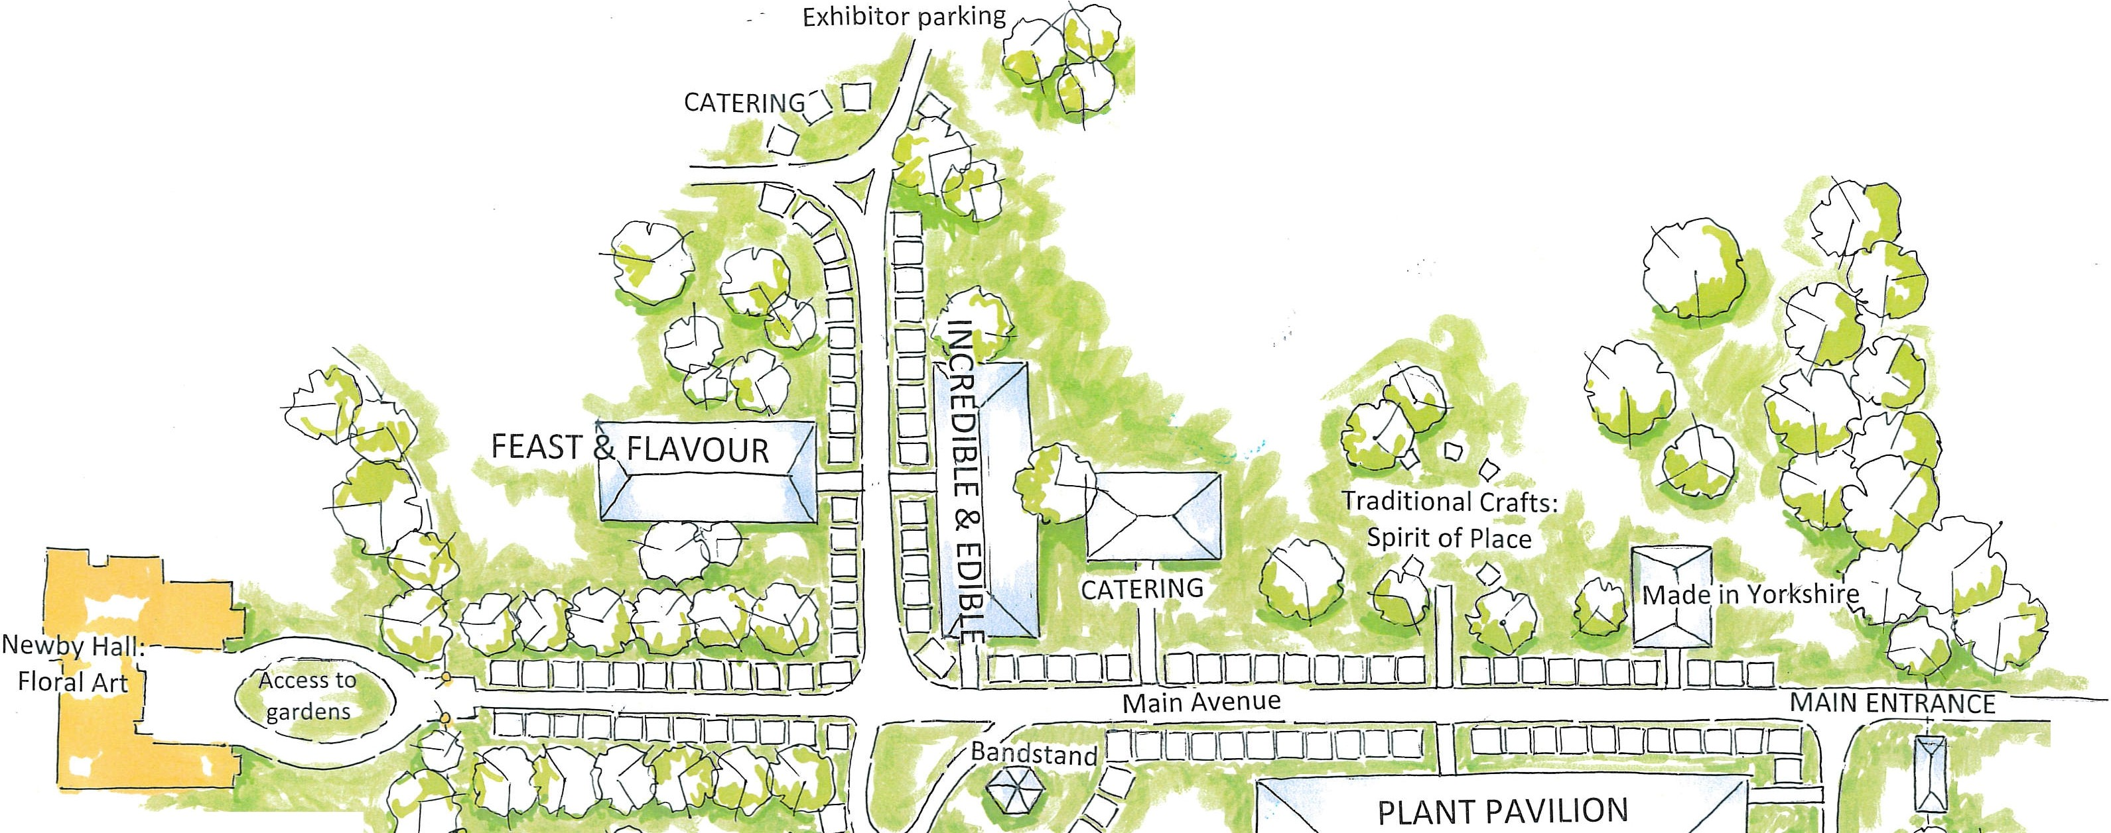
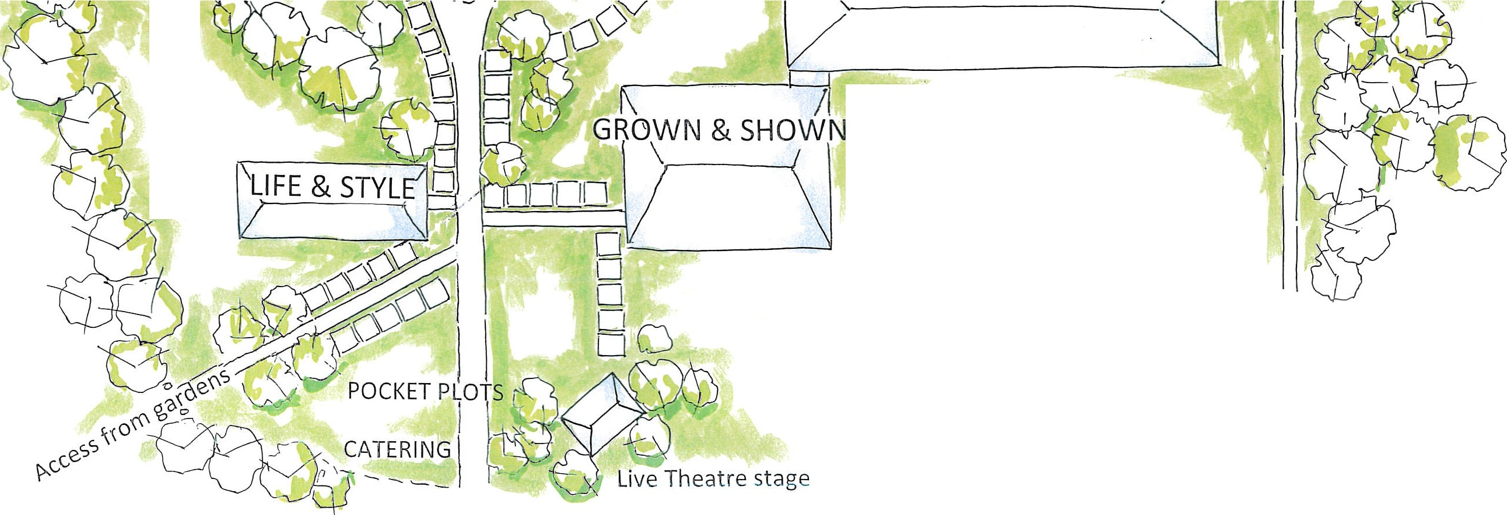
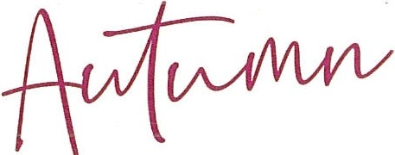

How To Find Newby Hall

Newby Hall & Gardens, Estate Office, Newby Hall, Ripon, North Yorkshire, HG4 5AE (If following SAT NAV please use HG4 5AJ).

Telephone: 01423 322583
Newby Hall is just a few miles from the A1(M), the main London to Edinburgh motorway. Close by are the magnificent Yorkshire Dales, North Yorkshire Moors National Parks and the historic cities of York and Ripon.

Travelling via the A1(M):
From South: 4 miles off A1(M) from Jct. 48 (signposted)
From North: 4 miles off A1(M) from Jct. 49 (signposted)

Travelling from Harrogate / Ripon:
Follow the A61 to Ripon and turn onto the B6265 (Boroughbridge Road). Follow the brown tourist signs to Newby.

SAT NAV
If you are using a Sat Nav to find your way to Newby please type in postcode HG4 5AJ this will bring you to the top of the drive.
- 4 miles (5-10mins) from Ripon City Centre
- 40 minutes (23 miles) from York
- 45 minutes (27 miles) north east of Leeds/Bradford Airport
30 minutes (15 miles) from Harrogate

Hotels & Pubs with accommodation
Grantley Hall | Ripon HG4 3ET | 01765 620070
The Old Deanery | Minster Road, Ripon, HG4 1QS | 01765 600003
The Sawley Arms | Sawley, Ripon HG4 3EQ | 01765 620642
The Unicorn Hotel Wetherspoon | Market Place East, Ripon HG4 1BP | 01765 643410
Ripon Spa Hotel | Park St, Ripon HG4 2BU | 01765 602172
The White Horse | 61 North St, Ripon HG4 1EN | 020 8089 8579
The George Carvery & Hotel | Dove Bank, Wormald Green, Harrogate HG3 3PR | 01765 676700
The Royal Oak | 36 Kirkgate, Ripon HG4 1PB | 01765 602284
Best Western Crown Hotel | Horsefair, Boroughbridge, York YO51 9LB | 0333 003 4104
The Bull Inn | Church St, West Tanfield, Ripon HG4 5JQ | 01677 470678
The Grantham Arms | Milby, Boroughbridge YO51 9BW | 01423 323980
Best Western Crown Hotel | Horsefair, Boroughbridge, York YO51 9LB | 0333 003 4104
The Black A Moor Inn | Boroughbridge Road, Ripon HG4 5AA | 01765 603511

B&Bs
Lock House B&B | Lock House Canalside, Boroughbridge YO51 9BL | 01423 324970
The Old Coach House | Greenfields, North Stainley, Ripon HG4 3HT | 07912 632296
Oak Tree House | Ripon HG4 5BY | 01765 603578
Mallard Grange | Aldfield, Ripon HG4 3BE | 01765 620242

Camping
Waingates Farm Huts | Waingates Farm, Roecliffe, YORK, YO51 9NE | 01423 740690
Venus | Bordercot, Ripon Road, Baldersby, Thirsk, YO7 4PS | 07950 342583
Boroughbridge Camping & Caravanning Club Site | Bar Lane, Roecliffe, Boroughbridge, YO51 9LS | 01423 322683
Yurtshire Fountains | Yew Tree House, Aldfield, Ripon, HG4 3BE | 01423 740783

